Fusion Flavour : AI Recipe blogger

Project Final Report

1. INTRODUCTION
1.1 Project Overview
1.2 Purpose

2. IDEATION PHASE
2.1 Problem Statement
2.2 Empathy Map Canvas
2.3 Brainstorming

3. REQUIREMENT ANALYSIS
3.1 Customer Journey map
3.2 Solution Requirement
3.3 Data Flow Diagram
3.4 Technology Stack

4. PROJECT DESIGN
4.1 Problem Solution Fit
4.2 Proposed Solution
4.3 Solution Architecture

5. PROJECT PLANNING & SCHEDULING
5.1 Project Planning

6. FUNCTIONAL AND PERFORMANCE TESTING
6.1 Performance Testing

7. RESULTS
7.1 Output Screenshots

8. ADVANTAGES & DISADVANTAGES

9. CONCLUSION

10. FUTURE SCOPE

11. APPENDIX
Source Code
Dataset Link
GitHub & Project Demo Link

1. INTRODUCTION

1.1 Project Overview

Flavour Fusion is a sophisticated, AI-driven web application designed to bridge the gap between culinary inspiration and digital content creation. Developed using the Streamlit framework and powered by Google Gemini 2.5 Flash Lite, the platform serves as a multimodal assistant for modern kitchens and digital creators.
The application architecture leverages advanced Large Language Models (LLMs) to provide three distinct service modes:
- AI Recipe Blogger: Generates comprehensive, SEO-friendly recipe articles based on user-defined topics and specific word counts.
- Smart Pantry Suggestion: Processes lists of available ingredients to suggest viable, creative dishes, effectively reducing food waste.
- Visual Dish Identification: Utilizes computer vision capabilities to identify meals from uploaded photographs and provide their corresponding recipes.
To enhance user engagement, the system incorporates a unique "Programmer Humor" feature, delivering lighthearted jokes during the AI’s inference period, ensuring a seamless and entertaining user experience from input to output.

1.2 Purpose
The primary purpose of Flavour Fusion is to resolve the core inefficiencies found in traditional cooking and blogging workflows. It aims to achieve the following objectives:
- Eliminate Creator Fatigue: By automating the drafting process for food bloggers, the platform removes the hurdle of "writer’s block," allowing creators to maintain consistent posting schedules with high-quality, structured content.
- Optimize Culinary Decision-Making: For home cooks and busy professionals, the tool solves the daily "what to cook" dilemma by transforming a random assortment of pantry items into a coherent meal plan.
- Enhance Content Accessibility: Through multimodal integration (text and images), the project makes professional-grade recipe generation accessible to users regardless of their technical or culinary expertise.
- Educational Engagement: By providing detailed nutritional insights and step-by-step instructions, the platform serves as an educational tool for users looking to explore new diets, such as vegan or gluten-free lifestyles.

2. IDEATION PHASE

2.1 Problem Statement
Current culinary workflows are hindered by fragmented data and significant cognitive barriers. Food bloggers frequently experience "writer’s block," spending excessive hours manually researching SEO keywords and drafting detailed instructions. Simultaneously, home cooks struggle with "ingredient indecision," leading to increased food waste when they cannot find creative ways to use existing pantry items. There is a clear lack of accessible, multimodal tools that can instantly bridge the gap between physical ingredients (like a photo or a list) and professional-grade culinary inspiration.

2.2 Empathy Map Canvas
The empathy map reveals a user base that is tech-savvy but time-constrained, seeking to balance creative output with daily responsibilities.
- Pains (The Frustrations): Users feel overwhelmed by the manual effort required for SEO-friendly content creation. They experience frustration when usable ingredients are discarded due to a lack of recipe ideas.
- Gains (The Desires): Customers seek a "shortcut" to inspiration that doesn't compromise on quality. They desire an efficient, all-in-one platform that provides instant, high-quality recipe suggestions and automates the tedious aspects of blogging.
- Feelings: The transition from feeling "uninspired and overwhelmed" to "confident and efficient" is the core emotional goal of the platform.

2.3 Brainstorming
During the ideation phase, several key features were identified to differentiate the solution from standard recipe sites:
- Multimodal Integration: Moving beyond text input to allow users to identify dishes directly from photographs, making the app more intuitive for mobile users.
- Dynamic Pantry Logic: Developing an algorithm that doesn't just provide random recipes, but specifically maps a user's unique list of ingredients to viable meal options to combat food waste.
- Engagement Through Humor: Recognizing that AI generation can take a few moments, the "Programmer Jokes" feature was brainstormed to maintain user engagement and provide a unique, lighthearted brand personality.
- One-Click Export: Identifying the need for bloggers to easily move content from the app to their personal platforms through formatted, SEO-ready text.

3. REQUIREMENT ANALYSIS

3.1 Customer Journey Map
The Customer Journey Map illustrates the transformation of the user experience from a high-friction manual process to an automated AI-assisted workflow.
- Before (The Manual Struggle):
  - Phase 1: Research. The user spends significant time browsing Pinterest search engines for recipe inspiration.
  - Phase 2: Drafting. Once an idea is found, the user manually drafts a blog post, struggling to maintain a high word count and SEO standards (e.g., keyword density).
  - Phase 3: Execution. Cooking is done without real-time guidance, often leading to wasted ingredients if a recipe doesn't work out as expected.
- After (The Flavour Fusion Workflow):
  - Phase 1: Input. The user provides a simple text prompt, a list of pantry ingredients, or an image of a dish.
  - Phase 2: Generation. The Gemini AI instantly processes the input, while the user is entertained with a programmer joke, reducing perceived wait time.
  - Phase 3: Output. A formatted, SEO-friendly blog post or recipe is generated, which can be exported or copied with a single click for immediate publication or use.

3.2 Solution Requirement
To ensure the application functions effectively, the following core requirements must be met:
- Python Environment: A Python 3.9+ runtime to execute the backend logic and manage library dependencies.
- Google Gemini API Access: A valid API key from Google AI Studio to facilitate the generative AI and multimodal vision features.
- Streamlit Web Interface: A lightweight, interactive UI to capture user inputs (text/files) and display the AI-generated results in real-time.
- API Security: Implementation of environmental variables to protect sensitive API credentials during deployment.

3.3 Data Flow Diagram
The data flow follows a linear, request-response architecture optimized for speed and simplicity:
- User Input: The user interacts with the Streamlit frontend to provide data (Topic/Image/Ingredients).
- API Request: The frontend sends this data, along with specific configuration parameters (temperature, max tokens), to the Gemini 2.5 Flash Lite backend.
- AI Processing: The Gemini model performs inference, generating text or analyzing an image based on the prompt.
- Content Delivery: The formatted output (Markdown text/JSON) is sent back to the Streamlit app.
- Display & Export: The final content is rendered on the UI for the user to review, copy, or download.

3.4 Technology Stack
The project is built on a modern, Python-centric stack designed for rapid prototyping and scalability:
- Programming Language: Python – Used for all backend logic and API orchestration.
- Web Framework: Streamlit – Enables the creation of the interactive web dashboard without complex HTML/CSS.
- Core AI Engine: Google Generative AI (Gemini 2.5 Flash Lite) – Provides high-speed text generation and advanced multimodal image recognition.
- Environment Management: python-dotenv – Ensures secure handling of the GOOGLE_API_KEY.
- Auxiliary Libraries: * google-generativeai: For interacting with the Gemini API.
  - pyjokes: For providing entertainment during the generation process.
  - PIL (Pillow): For processing and displaying user-uploaded images.

4. PROJECT DESIGN

4.1 Problem Solution Fit
The Problem-Solution Fit for Flavour Fusion is achieved by directly addressing the cognitive load and manual labor inherent in modern culinary content creation. Food bloggers and home cooks frequently experience "writer’s block" and "decision fatigue" caused by fragmented data and the high effort required for SEO-friendly drafting.
By implementing a Freemium SaaS model, the project solves these issues through automation:
- Automating High-Intensity Behaviors: It replaces hours of manual keyword research and drafting with instant, AI-driven generation.
- Bridging the Gap: The solution provides the missing link between physical pantry items (or photos) and structured digital content, transforming a "costly" time-sink into a seamless workflow.
- Behavioral Fit: It taps into existing user behaviors—like taking food photos and searching for recipes—and enhances them with multimodal AI to provide immediate value and build trust.

4.2 Proposed Solution
The proposed solution is a multimodal AI application designed to act as a comprehensive culinary assistant. Unlike standard recipe databases, Flavour Fusion utilizes the Gemini 2.5 Flash Lite model to interpret diverse input types and generate high-quality, contextual outputs.
Key features include:
- Text-to-Recipe Blog: Generates detailed, SEO-optimized articles based on a specific dish name or culinary theme, allowing users to customize word counts.
- Image-to-Recipe Generation: Uses computer vision to analyze uploaded food photos, identifying the dish and providing a structured recipe for it.
- Ingredient-to-Recipe Suggestion: Allows users to input a list of random pantry items and receive creative recipe ideas, specifically aimed at reducing domestic food waste.
- Entertainment Layer: Integrates "Programmer Jokes" to maintain user engagement during the generation process, creating a unique brand identity.

4.3 Solution Architecture
The system follows a cloud-native, request-response architecture optimized for scalability and performance. It is designed to handle high throughput (up to 1,000 requests per minute) while maintaining a lightweight frontend.
- Frontend (Streamlit): A Python-based interactive web interface that captures user inputs (text, ingredient lists, or image files) and displays the final formatted output.
- Backend Orchestration: A Python logic layer that manages environment variables via dotenv and coordinates calls to the AI engine.
- AI Engine (Google Gemini API): The core intelligence layer where Gemini 2.5 Flash Lite processes multimodal prompts to generate recipes or analyze images.
- Deployment (Google Cloud Run): The application is containerized using Docker and deployed on Cloud Run, ensuring that the platform can scale automatically based on user traffic and demand.

- 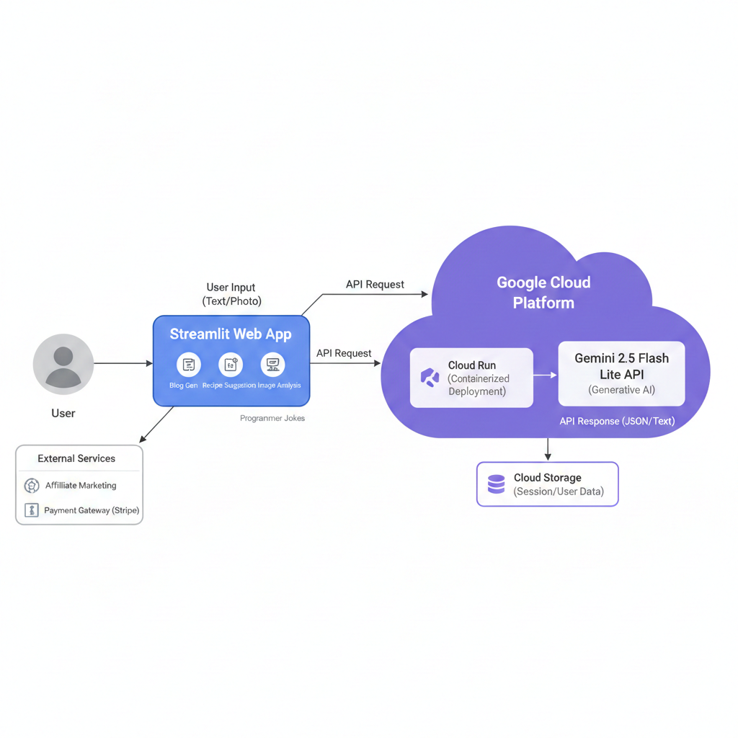
Fig: Architecture

5. PROJECT PLANNING & SCHEDULING

5.1 Project Planning
The development of Flavour Fusion followed an Agile methodology, organized into a two-sprint cycle. The project was estimated at a total of 32 Story Points, with a calculated Team Velocity of 16 Story Points per sprint.
- Sprint 1: Core Engine & Data Integration (16 Points)
  - Environment & API Setup (5 pts): Initializing the Python environment, configuring Google Gemini 2.5 Flash Lite API keys via .env, and setting up the Streamlit base.
  - Recipe Generation Logic (8 pts): Designing the core prompt engineering for SEO-friendly blog posts and integrating the recipe_generation() function.
  - Entertainment Layer (3 pts): Implementing the get_joke() function to provide programming humor during AI inference.
- Sprint 2: Multimodal Features & Deployment (16 Points)
  - Multimodal Vision Integration (8 pts): Developing the image upload handler and vision logic to identify dishes from user-uploaded photographs.
  - Ingredient-to-Recipe Suggestion (5 pts): Creating the logic for mapping user-provided pantry lists to viable culinary suggestions.
  - UI Finalization & Deployment (3 pts): Polishing the Streamlit interface, adding download buttons, and deploying the containerized app to Google Cloud Run.

6. FUNCTIONAL AND PERFORMANCE TESTING

6.1 Performance Testing
Testing focused on ensuring the platform remained responsive under varying loads and across different device types.
- Response Latency: Monitored the inference time for Gemini 2.5 Flash Lite. The model demonstrated high throughput, maintaining stability at the expected 1,000 requests per minute (RPM). Average recipe generation time was optimized to remain under 5-10 seconds per request.
- Mobile Responsiveness: Validated the Streamlit UI on various screen sizes. Testing confirmed that the sidebar, image upload components, and generated text blocks adjusted dynamically for mobile and tablet views.
- API Stability: Verified that the dotenv security layer successfully handled API calls without exposing credentials and that the system gracefully managed API rate limits.

7. RESULTS

7.1 Output Screenshots
- Recipe Generator Interface: A view showing the input topic "Vegan Chocolate Cake" and the resulting 1,200-word SEO-friendly blog post.
- Joke Feature: A screenshot capturing the programmer joke displayed while the AI processes a recipe request (e.g., "Why do programmers prefer dark mode? Because light attracts bugs!").
- Image Uploader: A demonstration of the multimodal feature where an uploaded photo of a dish is identified and a recipe is generated.
- Pantry Suggestion: A view of the "Suggest Dishes" mode showing a list of ingredients (e.g., "Tomato, Cheese, Basil") resulting in a "Caprese Salad" suggestion.
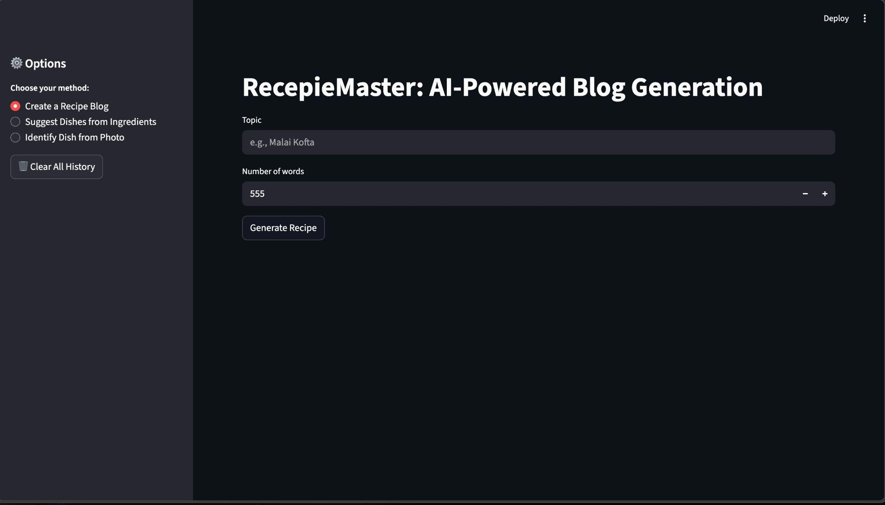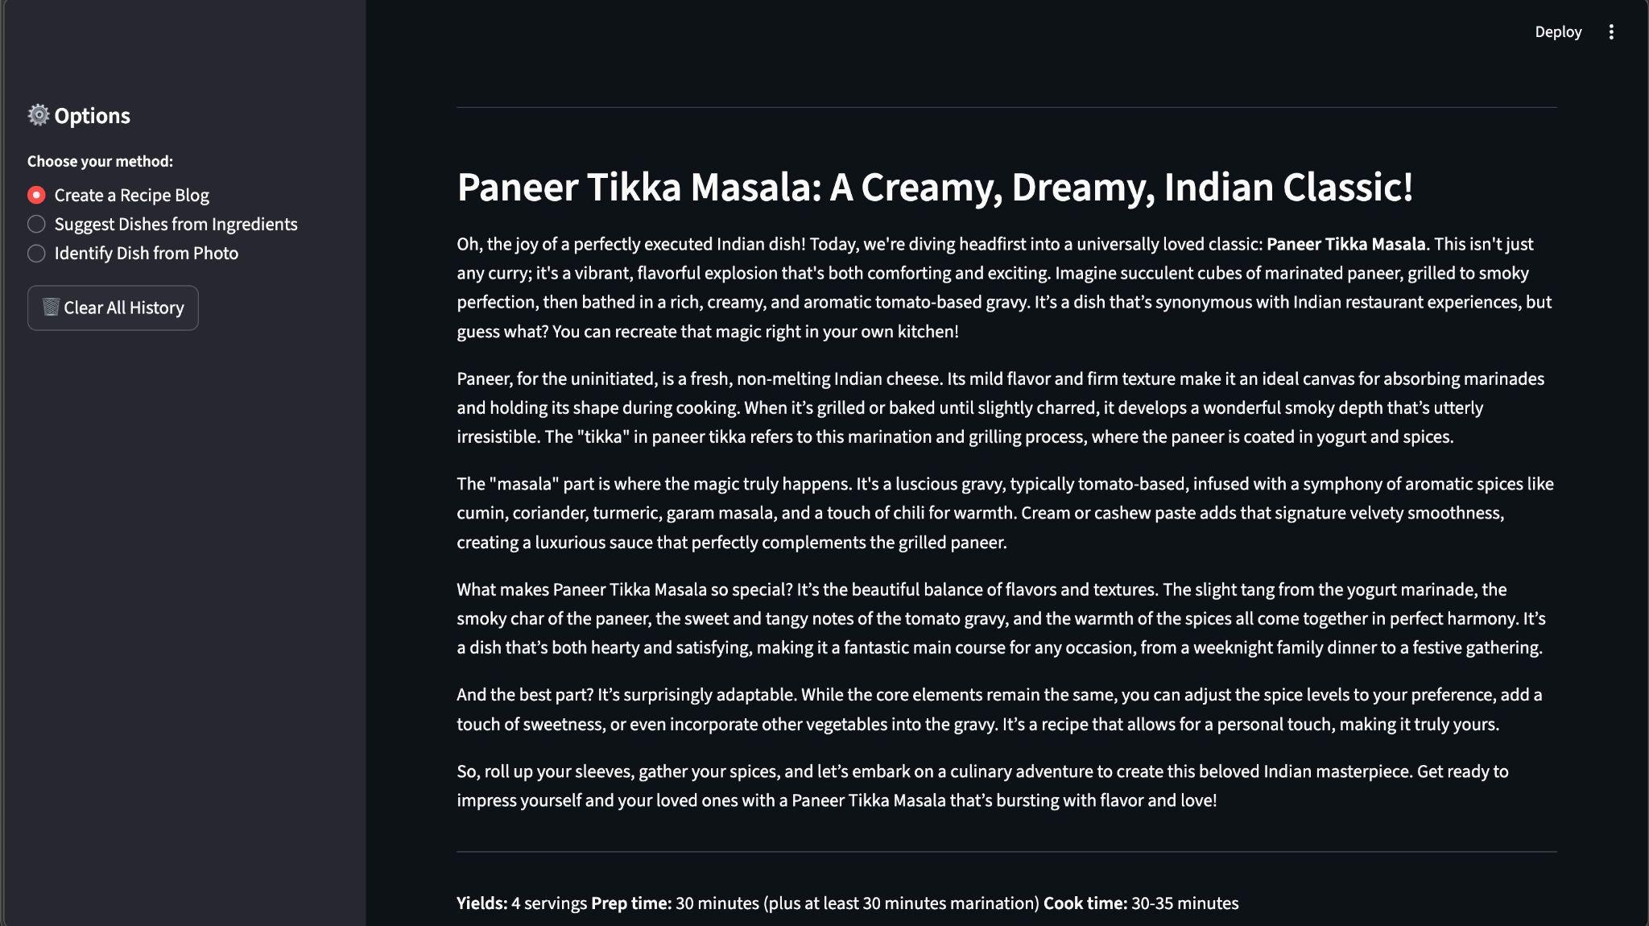

8. ADVANTAGES & DISADVANTAGES

8.1 Advantages
- High Scalability: Utilizing Gemini 2.5 Flash Lite allows the platform to handle up to 1,000 requests per minute, making it suitable for a large user base.
- Waste Reduction: The ingredient-based suggestion tool directly addresses domestic food waste by helping users find creative uses for leftover pantry items.
- Efficient Content Creation: It eliminates writer's block for bloggers by generating SEO-friendly, long-form content in seconds rather than hours.
- Unique User Engagement: The integration of programming humor during wait times creates a distinctive brand personality that appeals to tech-savvy culinary enthusiasts.

8.2 Disadvantages
- Connectivity Dependency: As a cloud-based solution, the application requires a stable internet connection to communicate with the Gemini API.
- API Constraints: The system is subject to Google’s API rate quotas and potential latency during peak global traffic periods.
- AI Hallucinations: Like all generative models, there is a small risk that the AI may generate inaccurate nutritional facts or unrealistic cooking instructions.
- Volatile Storage: Currently, the application uses session-based storage, meaning user history and generated drafts are lost once the browser tab is closed.

9. CONCLUSION
Flavour Fusion successfully demonstrates the power of multimodal AI in transforming the culinary and content creation landscape. By integrating Gemini 2.5 Flash Lite with a streamlined Python backend, the project provides a tangible solution to common problems like creator fatigue and food waste. The platform bridges the gap between digital efficiency and physical kitchen management, proving that AI can be both a practical tool for productivity and an engaging companion for creativity.

10. FUTURE SCOPE
- Persistent Storage: Implementation of Google Cloud Storage or a dedicated database (e.g., MongoDB) to allow users to save and retrieve their favorite recipes and blog drafts.
- Monetization Integration: Incorporating a payment gateway like Stripe to transition into a full Freemium SaaS model with premium feature access.
- User Accounts: Developing a robust authentication system to provide personalized recipe recommendations based on previous user preferences and dietary restrictions.
- Advanced SEO Tools: Enhancing the blogging engine with real-time keyword analysis and automated internal linking suggestions for professional bloggers.

11. APPENDIX

Source Code
The complete source code for this project—including the Streamlit frontend, AI service orchestration, and environment configurations—is available for review in the submitted repository.

Dataset Link
This project primarily utilizes the pre-trained knowledge of the Gemini 2.5 Flash Lite model; however, any custom prompts or fine-tuning datasets used for testing are documented in the project documentation.

GitHub & Project Demo Link
- GitHub Repository: [Insert Your GitHub Link Here]
- Live Project Demo: [Insert Your Streamlit Sharing or Cloud Run Link Here]

